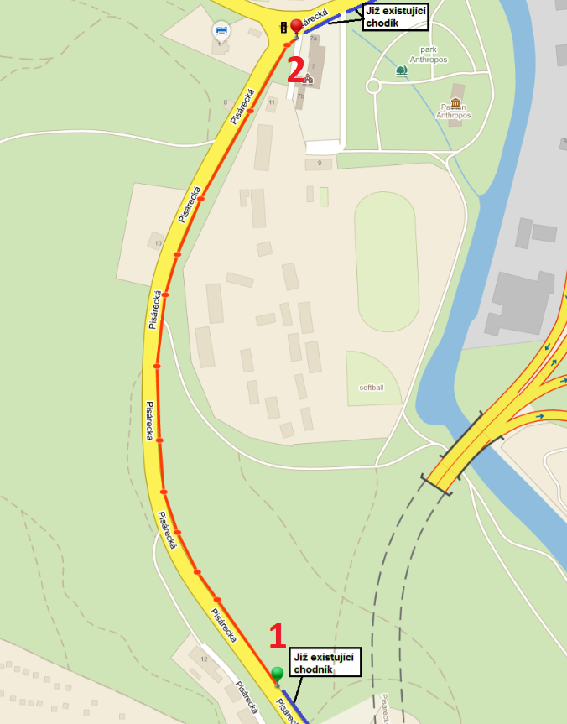

Bod 1 - 49.1856247N, 16.5646600E
Bod 2 - 49.1925928N, 16.5644456E

